Low-Level Design (LLD) — Assign Permissions Module
Attribute | Value
Module | Assign Permissions (Role → Permission Matrix)
Menu path | ADMINISTRATION → Assign Permissions
Landing page | assign_permissions.php
Application | Complaint / Dealer Portal
Stack (target) | Core PHP + MySQL (PDO)
Stack (current repo) | Core PHP + PostgreSQL via PDO
Document version | 1.0
Access | System Admin only (role id 6) — no RBAC module slug

â”€â”€â”€â”€â”€â”€â”€â”€â”€â”€â”€â”€â”€â”€â”€â”€â”€â”€â”€â”€â”€â”€â”€â”€â”€â”€â”€â”€â”€â”€â”€â”€

1. Module Overview

1.1 Purpose
System Administrators assign module permissions to application roles via a checkbox matrix. Grants are stored in role_permissions (soft-deleteable). At runtime, page/API/menu access resolves user_master.role → roles → role_permissions → active permissions / modules through rbac_* helpers.

1.2 Scope
In scope | Out of scope
Select role and load permission matrix | Modules master CRUD (modules.php)
Assign / unassign permissions for a role | Permissions master CRUD (permissions.php)
Soft-delete sync on save (insert / undelete / soft-delete) | Roles master CRUD (roles.php)
Select All / Clear All / per-module check-all UI | Per-user permission grants (not implemented)
Optional JSON matrix API | CSRF tokens (not implemented app-wide)

1.3 High-level architecture
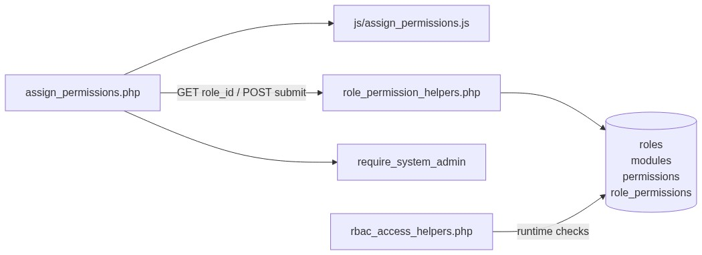
Figure 1 — High-level architecture
â”€â”€â”€â”€â”€â”€â”€â”€â”€â”€â”€â”€â”€â”€â”€â”€â”€â”€â”€â”€â”€â”€â”€â”€â”€â”€â”€â”€â”€â”€â”€â”€

2. Functional Requirements
ID | Requirement | Priority
FR-01 | System Admin can open Assign Permissions | Must
FR-02 | Load active roles into Role dropdown | Must
FR-03 | Load permission matrix for selected role (active modules/permissions) | Must
FR-04 | Show assigned count vs total permissions | Must
FR-05 | Save checked permission set for the role | Must
FR-06 | Soft-delete unchecked previously assigned permissions | Must
FR-07 | Undelete rows when a previously soft-deleted grant is re-checked | Must
FR-08 | Select All / Clear All / per-module select-all | Should
FR-09 | Auto-submit role select on change | Should
FR-10 | JSON API to fetch matrix by role_id | Could

â”€â”€â”€â”€â”€â”€â”€â”€â”€â”€â”€â”€â”€â”€â”€â”€â”€â”€â”€â”€â”€â”€â”€â”€â”€â”€â”€â”€â”€â”€â”€â”€

3. User Roles & Permissions

3.1 RBAC module slug
None. Assign Permissions is gated by System Admin (SYSTEM_ADMIN_ROLE = 6), not a permission slug.

3.2 Permission matrix (this module’s own access)
Capability | Gate
assign_permissions.php | require_system_admin($obconn)
api/role_permissions_get.php | admin_api_require_system_admin
Denied | Access denied. System Admin privileges required. → dashboard.php

assign_permissions.php is listed in rbac_admin_pages() and skips module-slug RBAC; System Admin check is authoritative.

3.3 Runtime effect of assignments
Consumer | Behavior
Pages | rbac_require_page_access via session_check.php
APIs | rbac_require_api_access
Sidebar | rbac_can_access_menu / rbac_sidebar_modules
Check | rbac_has_permission($conn, $moduleSlug, $permissionSlug)

There is no per-user permission table. Grants are role-based only.

3.4 Page / API mapping
Resource | Gate
assign_permissions.php | System Admin
api/role_permissions_get.php | System Admin API

â”€â”€â”€â”€â”€â”€â”€â”€â”€â”€â”€â”€â”€â”€â”€â”€â”€â”€â”€â”€â”€â”€â”€â”€â”€â”€â”€â”€â”€â”€â”€â”€

4. Business Rules
ID | Rule
BR-01 | Only active roles (role_get_all_active) appear in the Role dropdown.
BR-02 | Matrix shows only active modules (status = 'active', deleted_at IS NULL) and active permissions.
BR-03 | Role is required before save; role must exist (not soft-deleted).
BR-04 | Posted permission_ids[] are cast to unique positive integers.
BR-05 | Checked + no row → INSERT into role_permissions.
BR-06 | Checked + soft-deleted row → undelete (deleted_at = NULL; refresh created_by / created_at).
BR-07 | Unchecked + active row → soft-delete (deleted_at = CURRENT_TIMESTAMP).
BR-08 | Already-active checked rows are left unchanged.
BR-09 | Save does not validate that permission IDs exist or are active before insert.
BR-10 | Empty matrix when no active modules/permissions → informational alert; no Save button.
BR-11 | POST stays on the same page (no PRG redirect).
BR-12 | Runtime checks join live role_permissions with active permissions and modules.
BR-13 | Soft-delete of a role / module / permission cascades soft-delete of related role_permissions (via Roles / Modules / Permissions masters).
BR-14 | created_by on assign save = current_username().
BR-15 | No dedicated audit/activity log for assignment changes.

â”€â”€â”€â”€â”€â”€â”€â”€â”€â”€â”€â”€â”€â”€â”€â”€â”€â”€â”€â”€â”€â”€â”€â”€â”€â”€â”€â”€â”€â”€â”€â”€

5. Database Design

5.1 ER diagram
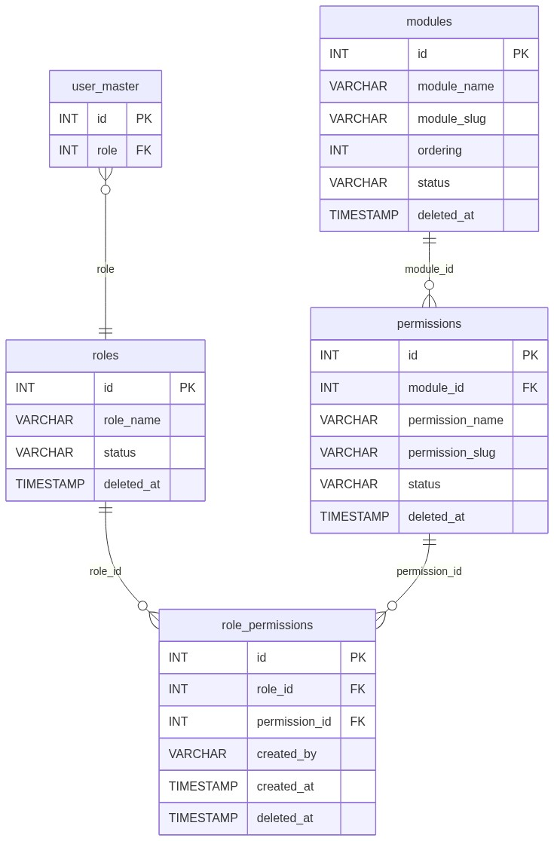
Figure 2 — Entity relationship diagram

5.2 Table: role_permissions
Column | MySQL type | Notes
id | INT UNSIGNED AUTO_INCREMENT | PK
role_id | INT | → roles.id
permission_id | INT | → permissions.id
created_by | VARCHAR(100) | Assigner username; refreshed on undelete
created_at | TIMESTAMP | Set on insert / undelete
deleted_at | TIMESTAMP NULL | Soft-delete

5.3 Related tables
Table | Role
roles | Role dropdown + existence check
modules | Matrix grouping (active only)
permissions | Checkbox rows (active only)
user_master | Runtime: user’s role drives access

5.4 Reference / lookup sources
Source | Usage
role_get_all_active() | Role <select>
permission_get_by_module_grouped() | Active module → permissions tree
role_permission_get_assigned_ids() | Checked state for selected role

â”€â”€â”€â”€â”€â”€â”€â”€â”€â”€â”€â”€â”€â”€â”€â”€â”€â”€â”€â”€â”€â”€â”€â”€â”€â”€â”€â”€â”€â”€â”€â”€

6. API / Backend Design

6.1 Page endpoints
Endpoint | Method | Auth | Description
assign_permissions.php | GET | System Admin | Role select; optional ?role_id= loads matrix
assign_permissions.php | POST submit_role_permissions | System Admin | Save assignment

6.2 JSON APIs

GET api/role_permissions_get.php?role_id=
System Admin only. Returns matrix for a role. Not used by the Assign Permissions page UI (page loads matrix server-side).
{
"role_id": 2,
"modules": [
{
"module_id": 1,
"module_name": "...",
"module_slug": "...",
"permissions": [
{
"id": 10,
"permission_name": "View",
"permission_slug": "view",
"assigned": true
}
]
}
]
}
Condition | Response
Missing / invalid role_id | { "modules": [] }
Role not found | HTTP 404 { "error": "Role not found." }

6.3 Supporting lookup APIs
N/A for the page (roles and matrix rendered in PHP). Catalog CRUD uses separate api/roles_*, api/modules_*, api/permissions_* endpoints outside this module’s UI.

6.4 Core PHP responsibilities
File | Role
includes/role_permission_helpers.php | Matrix load; save sync (insert / undelete / soft-delete)
includes/permission_helpers.php | permission_get_by_module_grouped
includes/role_helpers.php | Active roles; get by id
includes/admin_access_helpers.php | System Admin gate
includes/admin_api_guard.php | System Admin API gate
includes/rbac_access_helpers.php | Runtime page/API/menu permission checks
includes/rbac_page_guard.php | Thin page-guard wrapper
includes/rbac_helpers.php | Shared slug/status/display helpers

â”€â”€â”€â”€â”€â”€â”€â”€â”€â”€â”€â”€â”€â”€â”€â”€â”€â”€â”€â”€â”€â”€â”€â”€â”€â”€â”€â”€â”€â”€â”€â”€

7. Validation Rules

7.1 Server-side (assign page POST)
Field / rule | Message
role_id ≤ 0 / missing | Please select a role.
Role not found / soft-deleted | Selected role not found.
PDO failure on save | Failed to save permission assignment.
permission_ids[] | Cast to unique ints only — no existence / active check

7.2 Client-side (js/assign_permissions.js)
â€¢ Role <select> change auto-submits GET form when value non-empty
â€¢ Select All / Clear All / module check-all keep master + per-module indeterminate states
â€¢ Assigned count refreshed on checkbox change
â€¢ Success alert fades after 3 seconds
â€¢ No validate.js form constraints (checkbox matrix only)
â”€â”€â”€â”€â”€â”€â”€â”€â”€â”€â”€â”€â”€â”€â”€â”€â”€â”€â”€â”€â”€â”€â”€â”€â”€â”€â”€â”€â”€â”€â”€â”€

8. UI Screen Specifications

8.1 Landing — assign_permissions.php
Element | Spec
Subtitle | Assign module permissions to roles.
Card 1 | Select Role — native <select id="roleSelect"> + Load Permissions
Empty state | Select a role above to load permissions.
Card 2 | Permissions for {role_name}; Assigned: n / total
Empty matrix | No active modules or permissions found. Please create modules and permissions first.
Toolbar | Select All checkbox + Clear All button
Body | Module blocks; each with module check-all + permission checkboxes
CTA | Save Permission Assignment
Styles | css/rbac_assign.css (+ shared booking/complaint CSS)

8.2 Form fields
Control | Name | Notes
Role (GET) | role_id | Auto-submit on change
Role (POST hidden) | role_id | Selected role id
Submit flag | submit_role_permissions | Hidden 1
Permissions | permission_ids[] | Checkbox values = permission ids

8.3 Modals
None. Confirmation dialogs are not used on save.

8.4 Select2
N/A. Role select is a native HTML <select>.
â”€â”€â”€â”€â”€â”€â”€â”€â”€â”€â”€â”€â”€â”€â”€â”€â”€â”€â”€â”€â”€â”€â”€â”€â”€â”€â”€â”€â”€â”€â”€â”€

9. Database Flow

9.1 Save assignment (role_permission_save)
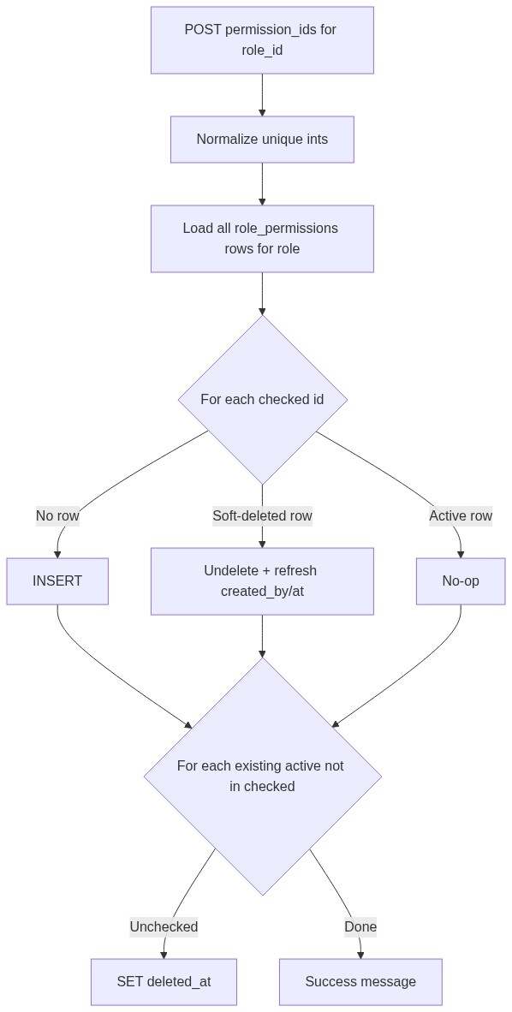
Figure 3 — Save assignment database flow

9.2 Soft-delete grant
UPDATE role_permissions
SET deleted_at = CURRENT_TIMESTAMP
WHERE id = :id;

9.3 Undelete grant
UPDATE role_permissions
SET deleted_at = NULL,
created_by = :created_by,
created_at = CURRENT_TIMESTAMP
WHERE id = :id;

9.4 Assigned ids query
SELECT permission_id
FROM role_permissions
WHERE role_id = :role_id
AND deleted_at IS NULL;

9.5 Matrix source query pattern
SELECT m.id AS module_id, m.module_name, m.module_slug, m.ordering,
p.id AS permission_id, p.permission_name, p.permission_slug, p.status
FROM modules m
LEFT JOIN permissions p
ON p.module_id = m.id
AND p.deleted_at IS NULL
AND p.status = 'active'
WHERE m.deleted_at IS NULL
AND m.status = 'active'
ORDER BY m.ordering ASC, m.module_name ASC, p.permission_name ASC;
â”€â”€â”€â”€â”€â”€â”€â”€â”€â”€â”€â”€â”€â”€â”€â”€â”€â”€â”€â”€â”€â”€â”€â”€â”€â”€â”€â”€â”€â”€â”€â”€

10. Sequence Diagram

10.1 Load matrix
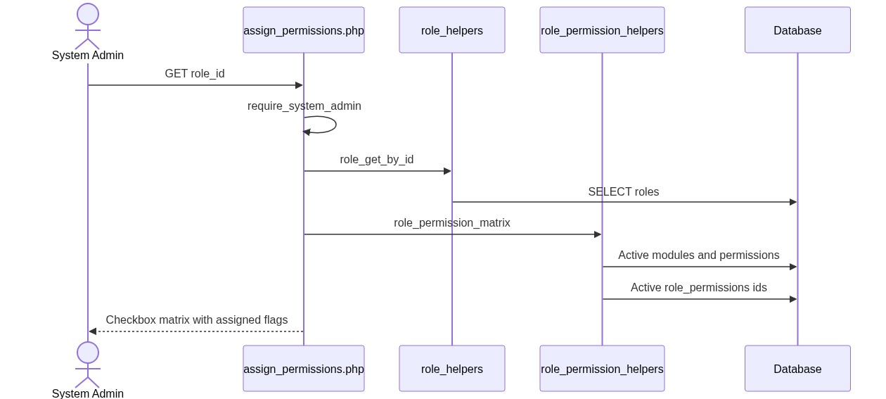
Figure 4 — Sequence: Load matrix

10.2 Save assignment
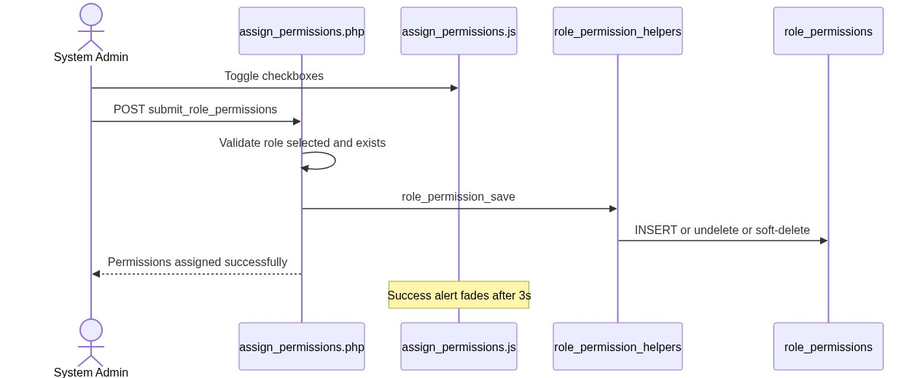
Figure 5 — Sequence: Save assignment
â”€â”€â”€â”€â”€â”€â”€â”€â”€â”€â”€â”€â”€â”€â”€â”€â”€â”€â”€â”€â”€â”€â”€â”€â”€â”€â”€â”€â”€â”€â”€â”€

11. Activity Diagram
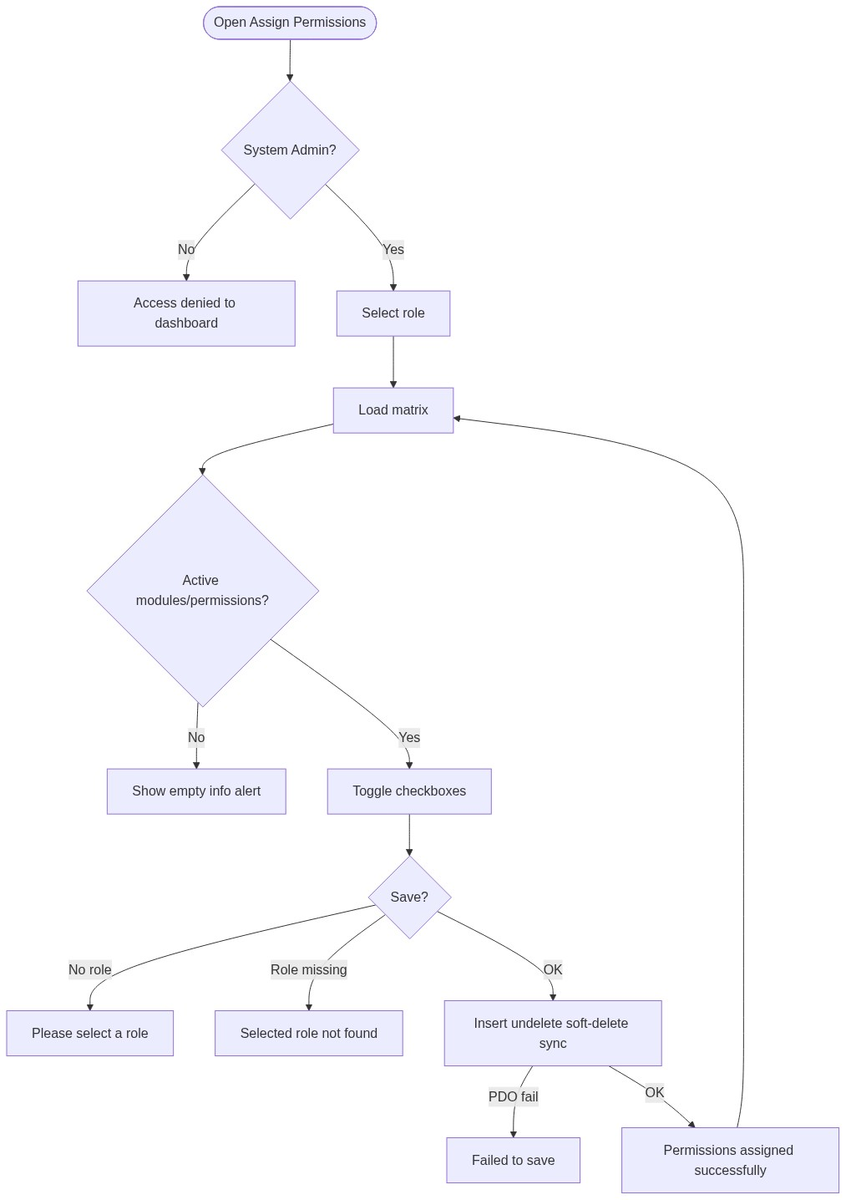
Figure 6 — Activity diagram
â”€â”€â”€â”€â”€â”€â”€â”€â”€â”€â”€â”€â”€â”€â”€â”€â”€â”€â”€â”€â”€â”€â”€â”€â”€â”€â”€â”€â”€â”€â”€â”€

12. Class / Module Diagram
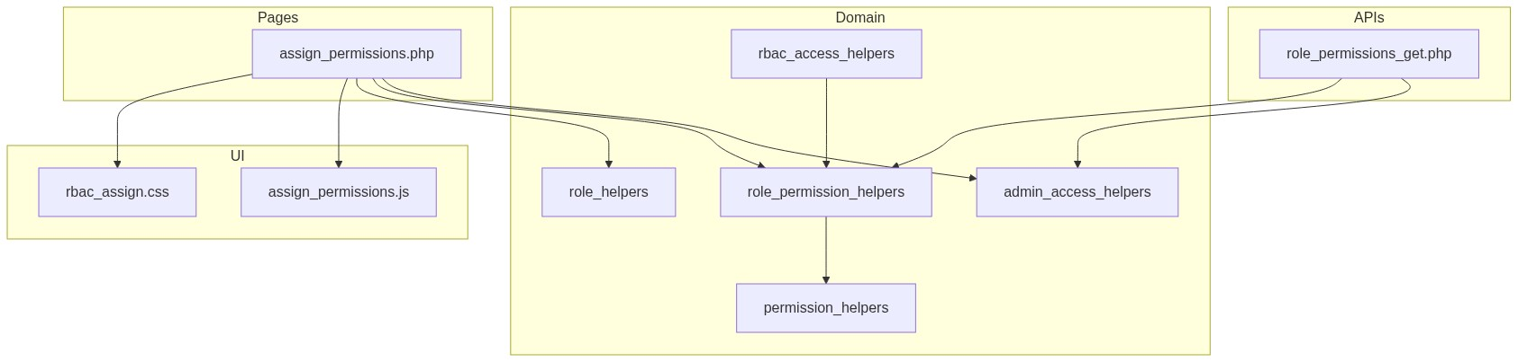
Figure 7 — Class / module diagram

12.1 Key functions
Function | Role
role_permission_matrix | Grouped modules + assigned flags
role_permission_save | Sync grants (insert / undelete / soft-delete)
role_permission_get_assigned_ids | Active permission ids for role
permission_get_by_module_grouped | Active catalog tree
role_get_all_active / role_get_by_id | Role options / existence
require_system_admin | Page gate
admin_api_require_system_admin | API gate
rbac_has_permission / rbac_role_has_permission | Runtime AuthZ
rbac_resolve_role_id | Map session role → roles.id
rbac_admin_pages | Skip module RBAC for admin screens
bootAssignPermissionsPage | Client UI boot

â”€â”€â”€â”€â”€â”€â”€â”€â”€â”€â”€â”€â”€â”€â”€â”€â”€â”€â”€â”€â”€â”€â”€â”€â”€â”€â”€â”€â”€â”€â”€â”€

13. Folder Structure
ComplaintManagement/
├── assign_permissions.php
├── access_denied.php
├── api/
│ └── role_permissions_get.php
├── includes/
│ ├── role_permission_helpers.php
│ ├── permission_helpers.php
│ ├── role_helpers.php
│ ├── module_helpers.php
│ ├── admin_access_helpers.php
│ ├── admin_api_guard.php
│ ├── rbac_access_helpers.php
│ ├── rbac_page_guard.php
│ └── rbac_helpers.php
├── js/
│ └── assign_permissions.js
├── css/
│ └── rbac_assign.css
└── docs/
└── LLD_Assign_Permissions_Module.md
Related catalog pages (out of scope for this UI, but feed the matrix): modules.php, permissions.php, roles.php.
â”€â”€â”€â”€â”€â”€â”€â”€â”€â”€â”€â”€â”€â”€â”€â”€â”€â”€â”€â”€â”€â”€â”€â”€â”€â”€â”€â”€â”€â”€â”€â”€

14. Error Handling
Layer | Pattern
Page POST | Local $error_message / $success_message alerts
Non-admin | Session flash → dashboard.php
API | JSON + HTTP 403 / 404
Client | Success alert auto-fade; no AJAX save

14.1 Common messages
Message | When
Permissions assigned successfully. | Save OK
Please select a role. | Missing role on POST
Selected role not found. | Invalid / deleted role
Failed to save permission assignment. | PDO exception
No active modules or permissions found. Please create modules and permissions first. | Empty catalog
Select a role above to load permissions. | No role selected
Access denied. System Admin privileges required. | Non-admin

â”€â”€â”€â”€â”€â”€â”€â”€â”€â”€â”€â”€â”€â”€â”€â”€â”€â”€â”€â”€â”€â”€â”€â”€â”€â”€â”€â”€â”€â”€â”€â”€

15. Security Considerations
Area | Control
Authorization | System Admin hard-gate on page + matrix API
Soft-delete | Active grants require deleted_at IS NULL
XSS | Matrix names escaped into $safePermissionMatrix before HTML
Runtime AuthZ | Live SQL via rbac_has_permission (not session-cached grants)
CSRF | Not implemented on assign form
Permission id trust | Posted ids not verified as active/existing before insert
Per-user grants | Not supported — role matrix only
Gaps | No PRG after POST; no audit trail of who changed which grant beyond created_by on insert/undelete

â”€â”€â”€â”€â”€â”€â”€â”€â”€â”€â”€â”€â”€â”€â”€â”€â”€â”€â”€â”€â”€â”€â”€â”€â”€â”€â”€â”€â”€â”€â”€â”€

16. Audit Logs

16.1 Built-in field-level audit
Field | Behavior
role_permissions.created_by | Set on insert; refreshed on undelete
role_permissions.created_at | Set on insert; refreshed on undelete
role_permissions.deleted_at | Soft-delete / clear on undelete
Dedicated assignment history table | Not implemented
rbac_clear_permissions_cache | Exists but unused for live checks; assign save does not call it

â”€â”€â”€â”€â”€â”€â”€â”€â”€â”€â”€â”€â”€â”€â”€â”€â”€â”€â”€â”€â”€â”€â”€â”€â”€â”€â”€â”€â”€â”€â”€â”€

17. Test Cases

17.1 Functional
ID | Scenario | Expected
TC-01 | Non-admin opens Assign Permissions | Denied to dashboard
TC-02 | Open page with no role | Empty “select a role” card
TC-03 | Select role with active catalog | Matrix loads; assigned count correct
TC-04 | Select All then Save | All permissions assigned for role
TC-05 | Clear All then Save | All prior grants soft-deleted
TC-06 | Uncheck one previously assigned | That role_permissions row soft-deleted
TC-07 | Re-check previously soft-deleted grant | Row undeleted; created_by / created_at refreshed
TC-08 | POST without role | Please select a role.
TC-09 | POST invalid role id | Selected role not found.
TC-10 | No active modules/permissions | Info alert; no Save button
TC-11 | Module check-all | Toggles only that module’s checkboxes
TC-12 | User with role lacking page permission | access_denied.php / API 403 at runtime
TC-13 | GET api/role_permissions_get.php as admin | JSON matrix
TC-14 | Soft-delete permission in Permissions master | Related role grants soft-deleted (cascade)

â”€â”€â”€â”€â”€â”€â”€â”€â”€â”€â”€â”€â”€â”€â”€â”€â”€â”€â”€â”€â”€â”€â”€â”€â”€â”€â”€â”€â”€â”€â”€â”€

18. Assumptions & Dependencies

18.1 Assumptions
1. Role id 6 is System Admin and may open this page.
2. Modules and permissions catalogs are maintained separately and marked active.
3. user_master.role stores roles.id (or resolvable role name) used by rbac_resolve_role_id.
4. Soft-delete is the only revoke mechanism; hard deletes of role_permissions are not used by this UI.
5. Document target stack Core PHP + MySQL; repo runs PostgreSQL.
6. System Admin bypass inside rbac_has_permission is not relied upon for module pages (checks go through grants).

18.2 Dependencies
Dependency | Purpose
Roles master | Role dropdown / existence
Modules + Permissions masters | Matrix catalog
admin_access_helpers | System Admin gate
rbac_access_helpers | Runtime enforcement of saved grants
jQuery + Bootstrap 5 | Alerts / fade-out
css/rbac_assign.css | Matrix layout

â”€â”€â”€â”€â”€â”€â”€â”€â”€â”€â”€â”€â”€â”€â”€â”€â”€â”€â”€â”€â”€â”€â”€â”€â”€â”€â”€â”€â”€â”€â”€â”€

Appendix A — Success / error flashes
Event | Message
Save OK | Permissions assigned successfully.
Missing role | Please select a role.
Bad role | Selected role not found.
Save fail | Failed to save permission assignment.

â”€â”€â”€â”€â”€â”€â”€â”€â”€â”€â”€â”€â”€â”€â”€â”€â”€â”€â”€â”€â”€â”€â”€â”€â”€â”€â”€â”€â”€â”€â”€â”€

Appendix B — Select2 control map
N/A. Role (#roleSelect) is a native HTML select (auto-submit on change).
â”€â”€â”€â”€â”€â”€â”€â”€â”€â”€â”€â”€â”€â”€â”€â”€â”€â”€â”€â”€â”€â”€â”€â”€â”€â”€â”€â”€â”€â”€â”€â”€

Appendix C — Save sync matrix
Prior state | Checked on save | Action
No row | Yes | INSERT
Soft-deleted row | Yes | Undelete + refresh created_by / created_at
Active row | Yes | No-op
Active row | No | Soft-delete
Soft-deleted row | No | No-op

â”€â”€â”€â”€â”€â”€â”€â”€â”€â”€â”€â”€â”€â”€â”€â”€â”€â”€â”€â”€â”€â”€â”€â”€â”€â”€â”€â”€â”€â”€â”€â”€

Appendix D — Runtime resolution path
Login → $_SESSION['role'] = user_master.role
→ rbac_resolve_role_id()
→ rbac_role_has_permission(module_slug, permission_slug)
→ JOIN role_permissions + permissions + modules
→ Allow page / API / menu OR access_denied / HTTP 403
â”€â”€â”€â”€â”€â”€â”€â”€â”€â”€â”€â”€â”€â”€â”€â”€â”€â”€â”€â”€â”€â”€â”€â”€â”€â”€â”€â”€â”€â”€â”€â”€
End of LLD — Assign Permissions Module

